Puzzle 2: Tic-tac-toe

**Description:**

Your boss, Evan Spiegel (you work for SnapChat outside Los Angeles, CA), has assigned you as a mentor to the new intern, Gavin Strong (from Subway). He’s never used Qt before and is stuck on the first training assignment, which is to create a tic-tac-toe game. Gavin went to lunch (Subway…where else?) for 50 minutes and your boss wants you to at least show Gavin where he went wrong in his code and finish it for him.

It’s Friday, 1 pm and you just want to be done with the week. If Gavin shows up before you finished, that means you’re probably going to be there helping him until he gets off at 5 pm. This is not an option. You have a ton of surfing to do + a dinner date at Gjelina, a very hard to get into restaurant on the beach.

Luckily, Gavin pretty much has the big idea. He’s just struggling on adding a mouse area, events (onClicked), anchors, toggling whether something is visible or not, etc. He even added the appropriate variables for you to use, so this shouldn’t take too long.

Download his code @ https://github.com/GavinStrong/Puzzle-2.git

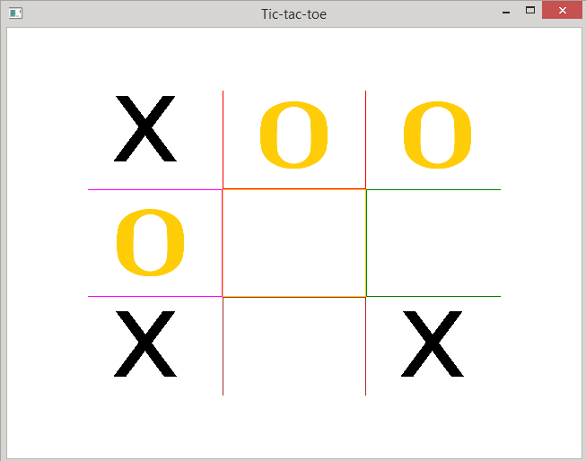

Requirements:

1. Mouse areas for each cell in the grid.
2. OnClicked method in each mouse area.
3. Use the bools game_over, first_player_turn and has_clicked appropriately.
4. Fill in function definition check_game_over().
5. Call check_game_over(), appropriately.
6. Game should function exactly how tic-tac-toe game is played by hand.

<https://en.wikipedia.org/wiki/Tic-tac-toe>